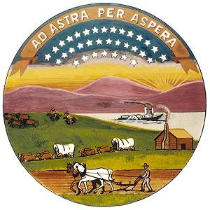

Rattlesnake Creek
Partnership

DRAFT FINAL
Third Four-Year Review of
Management Program
2009 - 2012

Basin Management Team

Division of Water Resources
Kansas Department of Agriculture
109 SW Ninth Street – 2nd Floor
Topeka, KS 66612-1283
785-296-6087

November 15, 2012
Table of Contents
Executive Summary 4
I. Introduction 4
II. Four-Year Evaluation of Management Program 5
A. Precipitation 6
B. Streamflow 8
January 10-Year Rolling Average of 25 cfs: 8
Minimum Desirable Streamflow (MDS) at the Zenith Streamflow Gage 9
C. Groundwater Level Trends 11
D. Water Use 15
Stream Corridor Area 15
Groundwater Management Area 17
Basinwide Area 18
III. Management Strategies 20
A. Water Transition Assistance Program 20
Other Purchase Programs 20
B. Water Banking 21
C. Flex Account 22
D. Conservation Practices and Irrigation Management 22
E. Voluntary Removal of End Guns 23
F. Enhanced Enforcement and Compliance 24
G. Water Appropriation Transfers 25
H. Mineral Intrusion Area-Replacement Wells 26
I. Augmentation 26
J. Low Head Dams 27
IV. Summary 27
V. Rattlesnake Creek Partner Position Papers 31
Figures & Tables
Figure 1: National Climatic Data Center and GMD 5 Weather Stations 7
Figure 2: Precipitation for the Rattlesnake Creek Subbasin 1939-2011 7
Figure 3: USGS Streamflow Gages 8
Figure 4: January Streamflow for USGS Zenith Gage 9
Figure 5: Zenith Streamflow and MDS 10
Figure 6: Priority Areas and Monitoring Well Network 11
Figure 7: Average Water Level Change by Priority Area 12
Figure 8: Cumulative Change in Feet since 2000 13
Figure 9: Interpolated Change in Water Levels 14
Figure 10: Points of Diversion and Groundwater Use Areas 15
Figure 11: Stream Corridor Groundwater Use 16
Figure 12: Groundwater Management Area Groundwater Use 17
Figure 13: Basinwide Area Groundwater Use 18
Figure 14: Reported Irrigated Acres, Priority Area 1, 2, 3, 4, Mineral Intrusion, Mystery River 19
Figure 15: Reported Irrigated Acres, Priority Area 5 and 7 19
Figure 16: Average Annual Zenith and Macksville Streamflow vs. Precipitation 1960-2011 28

Table 1: MDS values for Zenith gage (cfs) 10
Table 2: Average water level change by priority area 12
Table 3: Summary of Estimated Water Conservation (*denotes short-term savings) 29
Table 4: Summary of Progress 30

Executive Summary
The Rattlesnake Creek Partnership (Partnership) was formed over 18 years ago to cooperatively develop and implement solutions to water resource problems within the subbasin. Six years of negotiations resulted in the Partnership’s adoption of the jointly developed Rattlesnake Creek Management Program (Program) in 2000. Considerable time and resources have been expended on data gathering, monitoring, and hydrologic modeling. The subbasin’s variable hydrology, characterized by sequences of dry years with low streamflow and over-drafting on groundwater storage, and then wet periods with high streamflow and recharge, provides both challenges and opportunities in defining problems and addressing them. Through their participation in the work of the Partnership, each of the partners has increased their understanding of the area’s water resource issues.

The record shows declines in groundwater levels in the western portion of the subbasin and a downward trend in streamflow in the central and eastern portion of the subbasin. Since the Program began in 2000, limited reduction in water use has been realized through participation in incentive-based programs and enhanced compliance and enforcement, but the annual water savings claimed thus far is far less than the goal of 27,346 acre-feet of savings laid out by the Partnership in the Program.

At the end of the 12-year implementation period the Partnership finds that the Program has been successful in part and unsuccessful in part when considered against its originally stated purpose, goals, and objectives to address streamflow depletions and declines in groundwater levels. The program was not designed to address the individual interests of the partners, but to address the status of the overall basin.

This report consists of a summary of the data which was compiled and analyzed to review the performance of the Program, and in separate statements, the findings of each partner organization on the status of the Program as of the end of this third and final 4-year implementation period.

I. Introduction
In 1993, the Rattlesnake Creek Subbasin Partnership formed to cooperatively develop and implement water resource solutions. The partners agreed to use a community involvement approach as the guiding principle to address the water resource concerns within the subbasin. The Partnership includes Big Bend Groundwater Management District No. 5 (GMD 5), Water Protection Association of Central Kansas (Water PACK), Kansas Department of Agriculture-Division of Water Resources (KDA-DWR) and the U.S. Fish and Wildlife Service (USFWS), with a Cooperative Agreement signed June 1994.

The management program is intended to reduce the total amount of water used in the subbasin through methods outlined in the management program, particularly in identified priority areas. The management program addresses water resource solutions for both the short- and long-term. Active participation by water users in the subbasin is essential to achieving the objectives of reducing water use in the area.

In July 2000, the chief engineer of the Division of Water Resources approved the management program. August 1, 2000 was the official start date of the 12-year implementation schedule for the management program. The management program calls for a review of the management strategies every four years.

The first review was completed in August, 2004. At that time an addendum, listing programs that the Partnership wanted to focus on in the next four years, was attached to the review. These programs included end gun removal, irrigation transition assistance program (now Water Transition Assistance Program (WTAP)), the promotion of tillage practices to conserve water, the Environmental Quality Incentive Program (EQIP), a conservation credit point system for irrigators, and also the amendments to the Flex Account Program.

In December of 2009, the second 4-year review was submitted to the chief engineer with signatures from two of the Partners – USFWS and KDA-DWR. GMD 5 and Water PACK, chose not to sign the review, even though both participated in the completion of the report. The report included data analyses of precipitation, annual change in groundwater levels, streamflow at the Zenith gage, Minimal Desirable Streamflow (MDS) at the Zenith gage, and water use for the priority areas. It also included updated totals of water savings achieved through participation in programs established in the Rattlesnake Creek subbasin.

During the third-review period, GMD5 with participation of the other partners developed a quantitative hydrogeological model of the basin.

II. Four-Year Evaluation of Management Program
The management program outlines the process for evaluation and for the review and evaluation conducted at least every 4 years (4, 8 and 12 years). Each four-year evaluation provides an opportunity to determine the success of the new management program and allows for changes to the program to enhance the effectiveness. A review of each specific management strategy will occur to determine the effectiveness and if improvements are necessary to meet long-term goals.

As stated in the management program, each four-year review evaluation is to include at least the following criteria:

1. Determine if a January 10-year rolling average of 25 cubic feet per second (cfs) is achieved at the Zenith streamflow gage station.
2. Evaluation of Minimum Desirable Streamflow (MDS).
3. Achieve reduction of at least 4% in water use every four years with an objective of 12% by the end of the 12-year program in the Stream Corridor area.
4. Review of the 10-year rolling average annual water use and compare to target values outlined.
5. Stabilize water levels in high decline areas.
6. Stabilize water levels outside the groundwater priority areas.
7. Review of each management strategy and compare to target values:
- Water Rights Purchase Program
- Water Banking
- Flex Accounts
- Conservation Practices and Irrigation Management
- Voluntary Removal of End Guns
- Enhanced Compliance and Enforcement Activities
- Water Appropriation Transfers
- Mineral Intrusion Area – Replacement Wells
- Augmentation
- Low Head Dams
- Alternative Actions

A. Precipitation
For this analysis, data is used from four weather stations in the National Climatic Data Center network and two weather stations in the GMD 5 network. The six stations include Bucklin in Ford County, Greensburg in Kiowa County, Trousdale 1NE in Edwards County, Hudson in Stafford County, Greensburg in Kiowa County and Macksville in Stafford County (Figure 1). The analysis includes provisional data provided by the Kansas State Climatologist, Mary Knapp. The historical average of the subbasin since 1948 is 24.2 inches. Precipitation in the Rattlesnake Creek Subbasin can have large annual variation. For example in 2009 and 2010, the subbasin averaged 23.9 and 27.2 inches, respectively, but in 2011 the total average precipitation was 14.6 inches (Figure 2). During the three most recent years, the subbasin had one year near average, one year above average and one year significantly below average.
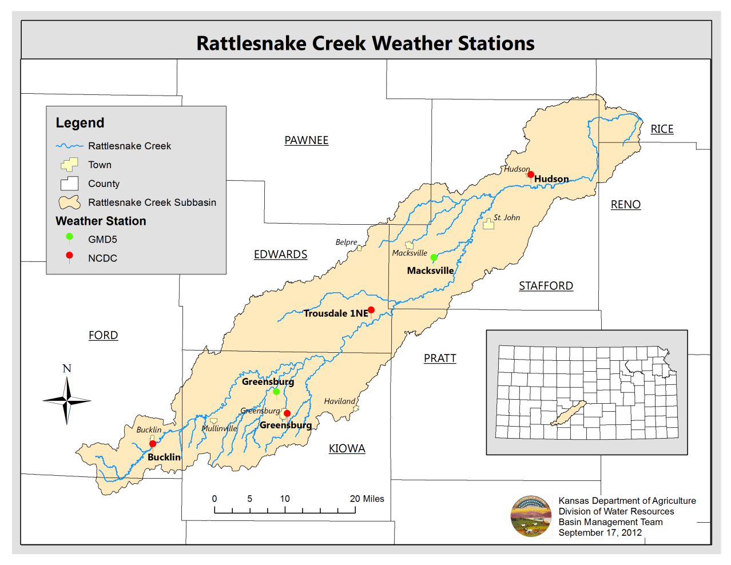
Figure 1: National Climatic Data Center and GMD 5 Weather Stations
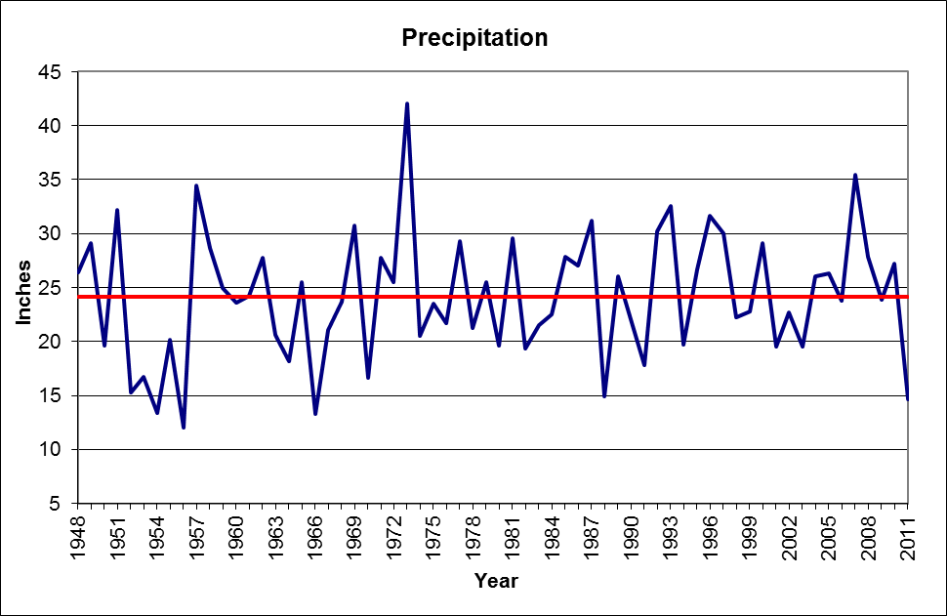
Figure 2: Precipitation for the Rattlesnake Creek Subbasin 1939-2011

B. Streamflow
The following map (Figure 3) shows the location of both United States Geological Survey (USGS) streamflow gages in the Rattlesnake Creek subbasin. Most of the analysis looks at the Zenith streamflow gage, but Figure 16 shows the annual streamflow for both Zenith and Macksville compared to annual precipitation. The Macksville streamflow gage is further upstream and has been in operation longer than the Zenith streamflow gage.
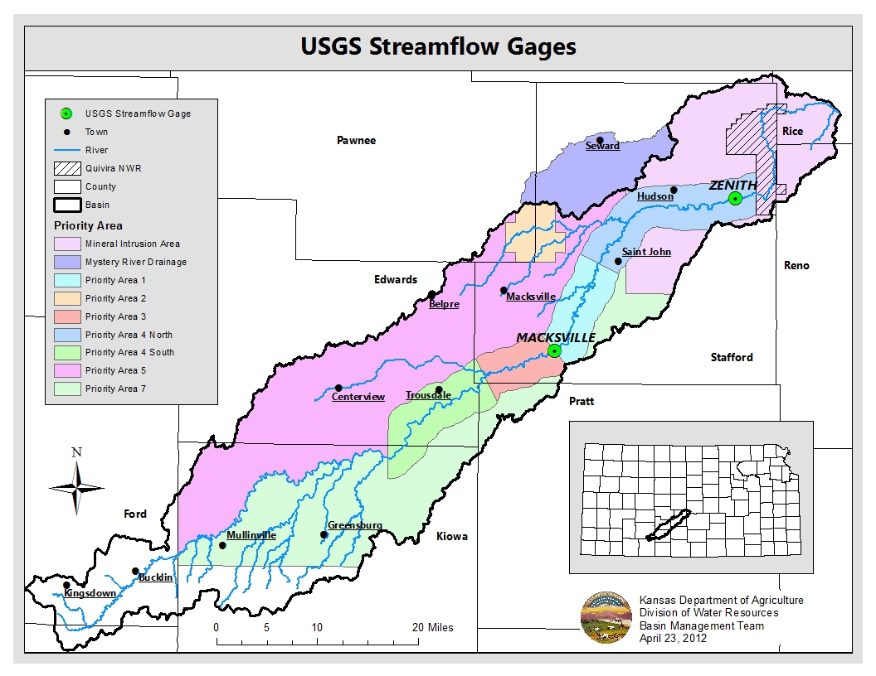
Figure 3: USGS Streamflow Gages

January 10-Year Rolling Average of 25 cfs:
The management program established a goal (III, A.) to meet and maintain a 10-year average of 25 cfs at the Zenith USGS streamflow gage during the month of January. Average January streamflow has declined since its peak in 1998. As a result, the 10-year rolling average of past years streamflow, including years before the program started, has declined since 2002. In 2009, 2010 and 2011, January streamflows were above 25 cfs, but the 10-year rolling average sank below 25 cfs. In 2012, streamflow in January was significantly below 25 cfs and the 10-year rolling average declined further (Figure 4). The original Rattlesnake Management Program states, “By achieving 25 cfs on average during January at the Zenith gage, base flows should be restored to Rattlesnake Creek. If the average January streamflow reaches 25 cfs, the reduction in water use should be adjusted even if the amount of water use is not 29,284 acre-feet on average, as the streamflow is the goal and the change in water use is only a means to achieve it. Analysis of streamflow data should be used to evaluate whether the trend in streamflows has moved to a positive trend or not.” See Figure 4: January Streamflow for USGS Zenith Gage

Beginning in 2009, the 10-year rolling average dropped below the 25 cfs objective and has remained below since.

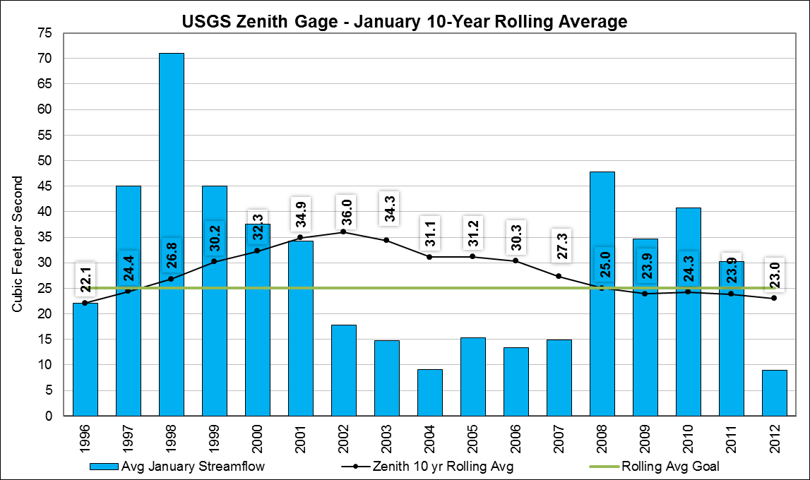
Figure 4: January Streamflow for USGS Zenith Gage

Minimum Desirable Streamflow (MDS) at the Zenith Streamflow Gage
In 1984, the Kansas Legislature amended the Kansas Water Appropriation Act to include Minimum Desirable Streamflow (MDS). Once a streamflow gage station records streamflow for seven consecutive days below the MDS value set by the legislature, administration of water appropriations with a priority date after April 12, 1984 can begin and will not cease until the gage has recorded fourteen consecutive days above the MDS value. The chief engineer can prohibit the use of certain diversions for this period if they are affecting streamflow. The Zenith streamflow gage is a MDS gage station (Table 1).

Table 1: MDS values for Zenith gage (cfs)
Mo. | Jan | Feb | Mar | Apr | May | June | July | Aug | Sept | Oct | Nov | Dec
MDS | 15 | 15 | 15 | 15 | 15 | 15 | 5 | 3 | 3 | 3 | 10 | 15

MDS has never been administered at the Zenith gage even though streamflow has fallen below MDS criterion. This is due to the complexity of the stream-aquifer interaction of the area making it difficult to determine which diversions would have a direct effect on streamflow. The GMD 5 model may be able to help with these determinations, but has not yet been used to do so.

The beginning years, 2009 and 2010, of the third 4-year review maintained MDS at the Zenith gage. In 2011, the Zenith gage only met MDS criterion for 48% of the year (Figure 5).

Figure 5: Zenith Streamflow and MDS

C. Groundwater Level Trends
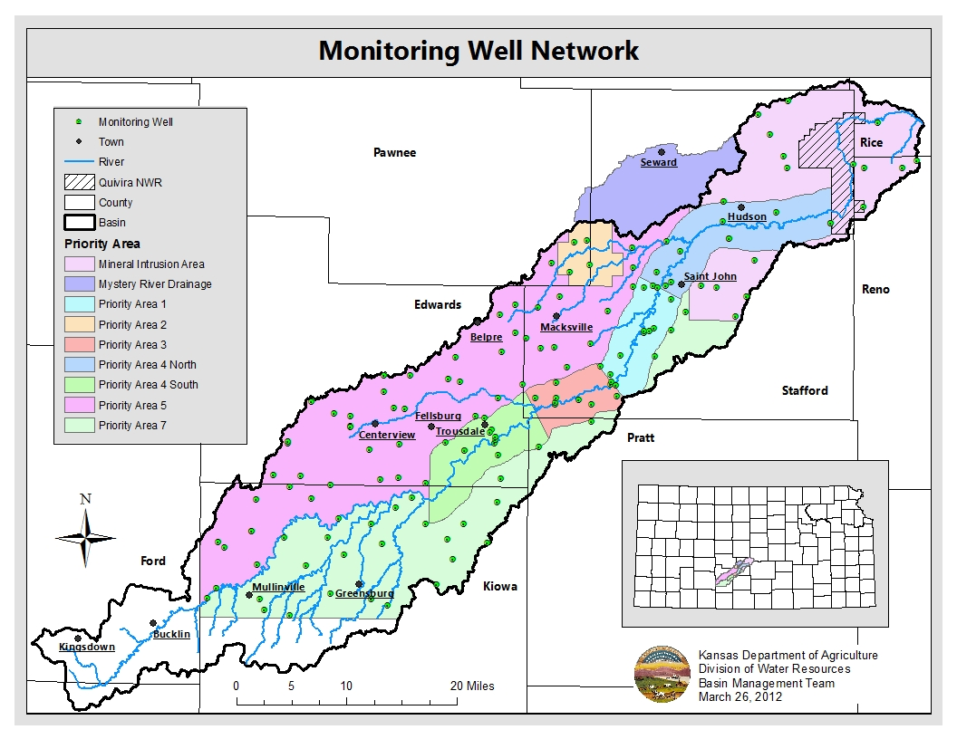
Figure 6: Priority Areas and Monitoring Well Network

Monitoring wells from all the priority areas are measured annually during winter (December, January and February). The wells are averaged for each priority area. Priority Area 4 was divided into a north and south (Figure 6). For the 2012 review, the GMD 5 transect wells were included. Many of the measurements for these wells did not begin until 2001 or 2002 and are located in Priority Areas 1 and 3.

The basinwide groundwater level average in 2009 showed an increase of 0.55 feet (Table 2). The following year levels continued to increase, averaging 0.70 feet. In 2011, the basinwide average groundwater levels showed an average decline of 0.56 feet then worsened to an average decline of 3.11 feet in 2012. The largest declines from 2011-2012 were in Priority Area 4S (4.0 ft) while the smallest declines were located in Priority Area 7 (2.16 ft).

Table 2: Average water level change by priority area
Year | 1 | 2 | 3 | 4N | 4S | 5 | 7 | MIA | Average
# Wells | 14 | 4 | 9 | 11 | 11 | 52 | 27 | 18
2001 | -0.93 | -0.24 | 0.33 | -0.15 | -0.40 | -0.07 | 0.11 | -0.94 | -0.29
2002 | -1.26 | 0.62 | -1.52 | -0.45 | -1.60 | -1.54 | -0.37 | -1.00 | -0.89
2003 | 0.77 | -2.39 | -1.03 | -0.74 | -2.71 | -2.06 | -1.97 | -0.71 | -1.35
2004 | -1.26 | -1.93 | -1.58 | -0.77 | -2.04 | -1.59 | -1.35 | -0.77 | -1.41
2005 | 0.77 | 0.35 | 0.99 | 1.18 | -1.09 | -0.36 | -0.03 | 0.88 | 0.34
2006 | 0.91 | -0.34 | 0.76 | -0.28 | -0.32 | -0.25 | -0.84 | 0.46 | 0.01
2007 | -0.98 | -0.73 | -2.13 | -0.67 | -2.20 | -1.90 | -1.18 | -2.08 | -1.48
2008 | 3.00 | 5.37 | 4.39 | 2.85 | 5.17 | 3.29 | 1.45 | 4.73 | 3.78
2009 | -0.01 | 1.14 | 0.22 | 0.70 | 0.45 | 0.39 | 0.14 | 1.39 | 0.55
2010 | 0.69 | 1.68 | 0.44 | 0.28 | 0.89 | 0.12 | 0.57 | 0.96 | 0.70
2011 | -0.48 | -0.50 | -0.24 | -0.91 | -0.03 | 0.24 | -0.27 | -2.27 | -0.56
2012 | -2.41 | -3.62 | -3.47 | -2.76 | -4.00 | -2.71 | -2.16 | -3.74 | -3.11

Table 2 shows the average annual change in water levels starting in 2001. The change between 2008 and 2009 water levels had a rise in all the priority areas except for PA1, which had a slight decline of 0.01 feet. In 2010, water levels did rise in all the priority areas. In 2011 only PA5 had an increase in water levels. In 2012, the decline continued. In fact, 2012 had some of the highest declines during the period of record with an average decline of 3.11 feet.
Figure 7 charts the annual change for each priority area. Figure 8 charts the cumulative change of feet by priority area.

Figure 7: Average Water Level Change by Priority Area

Figure 8: Cumulative Change in Feet since 2000

Figure 9 highlights the change in water levels for the entire implementation period (2001-2012) and for each review period (2001-2004, 2005-2008 and 2009-2012). The maps were created by plotting monitoring wells with values in the start and end years (i.e. 2001 and 2012) for each map. The difference in feet between the two years was interpolated employing the kriging method over the subbasin. On the overall map, additional layers such as county lines, roads and active points of diversion were included. All four maps have Rattlesnake Creek and the priority areas defined by the Partnership.

The 2001–2012 map shows that Rattlesnake Creek subbasin has experienced declines in water levels throughout most of the subbasin. The subbasin does have pockets of increase in Priority Area 2, near the line of Priority Areas 3 and 5 and Mineral Intrusion Area. The largest declines (oranges and reds) are located in the upper basin especially throughout Edwards County and northern Kiowa County.

For the third 4-year implementation review (2009-2012), water levels declined in all the priority areas. The largest declines were in the lower reaches of the subbasin especially near Quivira NWR. There is also a swath of larger declines in Priority Area 5 and 4S. The lesser declines are in the upper reaches of the subbasin and also in Priority Area 2 and 5.

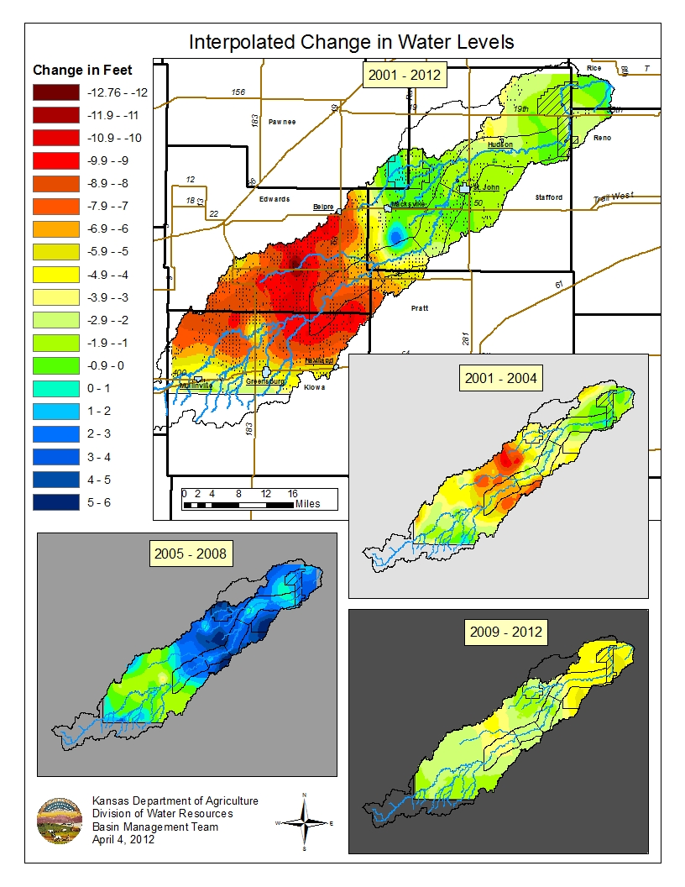
Figure 9: Interpolated Change in Water Levels

D. Water Use
Water use values and authorized quantities are an estimate based on the available information from the Kansas Department of Agriculture – Division of Water Resources. These values could change over time. The analysis included inactive water rights because they may have had use in the previous years. During 2011, a new program, Drought Term Permits, was implemented to assist irrigators during the 2011 drought. The program allowed for an irrigator to borrow a portion of the next year’s (2012) authorized quantity in order to complete the 2011 growing season. The following map (Figure 10) shows all the groundwater points of diversion and drought term permits. The map also differentiates between the three areas: Stream Corridor, Groundwater Management Area and Basinwide Area.

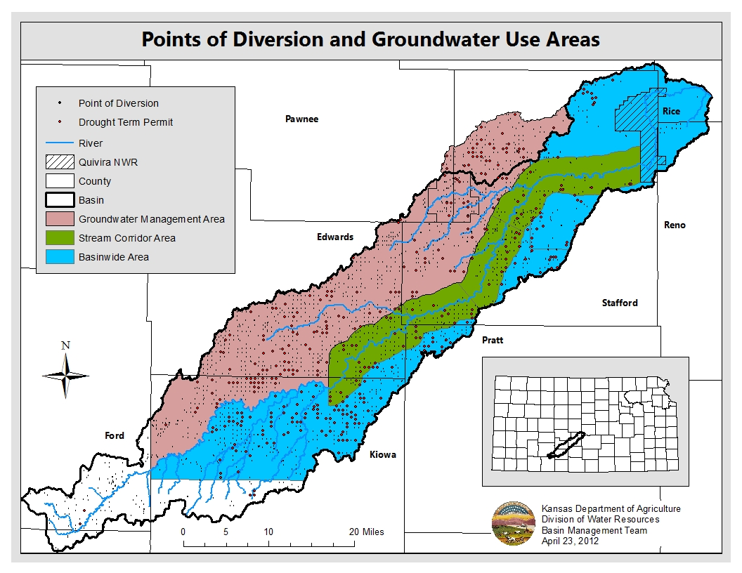
Figure 10: Points of Diversion and Groundwater Use Areas

Stream Corridor Area
The Stream Corridor Area is described as a 4-mile wide zone, two miles on either side of the Rattlesnake Creek from the Quivira National Wildlife Refuge boundary where the Rattlesnake Creek enters the refuge to the west side of Section 10, Township 27 South, Range 17 West in Kiowa County (Figure 10). Section 10 line that extends north and south creates the cut off point for the upper end of the corridor area. This area was selected based on the hydrologic relationship to the stream. The corridor was divided into separate areas to target water right purchase funds in higher priority areas.

The objective is to reduce average groundwater use within the corridor by 4% during each review period, totaling a 12% reduction by 2012. These numbers are based on the 1987-1996 base period average water use. The corridor consists of Priority Areas 1, 3 and 4. The 12% reduction objective was established in the 2000 Rattlesnake Creek Management Program Proposal and the Partnership agreed to set it at 29,284 acre-feet of groundwater use. This was calculated based on 72% average water use of the authorized quantity for the corridor. Water use for 2012 was unavailable at the time of this review.

Figure 11 charts the groundwater use totals since 1992, the 10-year rolling average starting in 2001 and the 12% reduction objective set forth by the Partnership. Ten-year rolling average water use in 2009 was 31,430 acre-feet, 31,345 acre-feet in 2010 and 31,987 acre-feet in 2011. Over the last ten years, the rolling average water use in the stream corridor area has not dropped below the established objective. Average actual water use since the base period was 31,673 acre-feet.

Figure 11: Stream Corridor Groundwater Use

Groundwater Management Area
The current management objective for groundwater use is to decrease use in both Priority Area 5 (formerly known as 1st Groundwater Unit) and the High Decline Area (Priority Area 2) by 16% from the 1987-1996 average water use. The original Rattlesnake Creek Management Program also included the Mystery River area so it was also included in the analysis.

Based on groundwater use from 1987-1996 in the Groundwater Management Area, a 16% reduction in average groundwater use calculates to 84,996 acre-feet. The 10-year rolling average groundwater use in 2009 was 101,635 acre-feet. In 2010, it declined to 100,750 acre-feet, but in 2011 it rose to 102,447 acre-feet. Since 1997, annual water use has exceeded the established objective (Figure 12). The 10-year rolling average was not met from 2009-2011. Water use for 2012 was not available at the time of this analysis.

Figure 12: Groundwater Management Area Groundwater Use

Basinwide Area
The basinwide area includes Priority Area 7 and the groundwater rights in the Mineral Intrusion Area. The 10-year rolling average water use for this area in 2009 was 53,388 acre-feet. It increased in 2010 to 53,736 acre-feet and also in 2011 to a total of 54,985 acre-feet. The objective for this area is to achieve an annual groundwater use of 46,906 acre-feet as was established in the 2000 Rattlesnake Creek Management Program. The 10-year rolling average objective was not met from 2009-2011 (Figure 13).

Figure 13: Basinwide Area Groundwater Use

The following two graphs, Figure 14 and Figure 15, chart the irrigated acres reported for each priority area. Due to the scale difference Priority Area 5 and 7 were plotted on a separate graph. Since the implementation of the Rattlesnake Creek Management Program, the subbasin has not had a large shift in irrigated acres.

Figure 14: Reported Irrigated Acres, Priority Area 1, 2, 3, 4, Mineral Intrusion, Mystery River

Figure 15: Reported Irrigated Acres, Priority Area 5 and 7

III. Management Strategies
In order to more accurately quantify the water savings achieved through participation in various incentive programs, the Partnership considered historical data comparing actual water use with the authorized quantities of water rights in the subbasin. The Partnership found that, on average, water use is 72% of authorized quantity. This factor was incorporated into Table 1 of the Program and is used in this review to calculate water savings resulting from the management strategies described in the following sections.

A. Water Transition Assistance Program
In 2006, the State Conservation Commission (now Kansas Department of Agriculture – Division of Conservation) implemented the Water Transition Assistance Program (WTAP). WTAP is designed to decrease historic consumptive use in designated high priority areas, including the Rattlesnake Creek Subbasin, by providing cash incentives to irrigators for permanent retirement of their water rights. WTAP allows dryland farming after the water right is retired. When competing for WTAP funds, priority is given to water rights which, if dismissed, would have the greatest hydrologic benefits at the lowest possible bid price as determined by a variety of factors including distance from the stream system and position in the stream corridor. All other things being equal, priority is given to retiring most senior water rights. WTAP is funded by the state, authorized until 2022, and has a maximum annual budget of $1.5 million dollars.

One water right was enrolled in the Rattlesnake Creek Subbasin in 2007, the first year of enrollment. The authorized quantity of this right was 225 acre-feet and the average annual water savings is 162 acre-feet. In 2009 the WTAP purchase price was increased to $2,000 per acre-foot and two applications, with a combined authorized quantity of 518 acre-feet and average annual water savings of 373 acre-feet, were approved in the Rattlesnake Creek area. The water use savings of all three water rights in the Rattlesnake Creek priority areas is 535 acre-feet annually.

Other Purchase Programs
In 2006, GMD 5 purchased one water right, authorized quantity 195 acre-feet, in Priority Area 5. In 2008, GMD 5 purchased two water rights, total authorized quantity 66 acre-feet, in Priority Area 4. All three water rights are currently enrolled in the Water Right Conservation Program (WRCP), a contract with KDA-DWR that keeps the water rights viable and safe from abandonment in return for their non-use. WRCP contracts have limited time periods and water rights cannot be enrolled in the program indefinitely. The water right purchased in 2006 WRCP’s contract expires in December 2016 and the other two water rights WRCP contracts expire in December 2012. The average annual water use savings for the three water rights is an estimated 188 acre-feet while they are in the WRCP program.

The current management goal set out in the Program is 7,396 acre-feet of annual water savings.

B. Water Banking
The Kansas Legislature passed the Water Banking Act in 2001. The rules and regulations were adopted in 2004 with the Charter for the Central Kansas Water Bank (CKWB) following in 2005. The CKWB comprises the entire Big Bend Groundwater Management District 5 and is administered from the District office.

A groundwater bank allows water users the ability to deposit all or part of their water right into the bank and receive compensation when another water user leases the water. In addition, water users can establish a safe deposit account that allows a carryover of a portion of annual unused water for use in later years. Attached to both the leases and deposits is a conservation component.

The goal of the water bank is to reduce water use in priority management areas. The CKWB charter requires a minimum ten percent savings in consumptive use and prevents the movement of water within two miles of the Rattlesnake Creek or to any area with over twenty feet of decline since predevelopment. Parameters used to determine the conservation component for each transaction are saturated thickness, sustainable yield, proximity to the stream, and the amount of groundwater decline since predevelopment.

The CKWB uses an online bulletin board system that allows water users the ability to post water available for deposit and lease. Banking operations are currently being reviewed, as prescribed by the charter, to determine if the program has positively affected the subbasin. Information about the CKWB, as well as the bulletin board itself, is available at http://www.gmd5.org/Water_Bank/.

During the Program’s 12-year implementation period, the CKWB saved 49 acre-feet in the safety deposit program and 51 acre-feet in the deposit-lease program. This resulted in a total average annual savings of 100 acre-feet while the water rights were deposited in the bank. The charter for the CKWB expired in 2012 and at the time of this review, a new charter has not been executed.

The water savings goal set out in the Program is 2,390 acre-feet.

C. Flex Account
Flex Accounts were established after the adoption of the Rattlesnake Creek Management Program and replaced the Five-Year Water Rights Program. Flex Accounts (K.A.R. 5-16-1 through 5-16-7) established a voluntary water right management program that enabled water users to manage their water rights in a manner which promotes conservation and efficiency, yet allows for crop demands in dry years.

Participants who filed for and received approval for a flex account would have received a five-year term permit which deposited a maximum quantity of water authorized for diversion in five consecutive calendar years. The program added the total actual water use for the period 1992 to 2002, divided by eleven, multiplied by 0.9 and then multiplied by five. The term permit included a 10% conservation component reflected in the total authorized amount for the five-year period.

The water savings goal set out in the Program is 953 acre-feet. There was no enrollment in this program by water right holders in the Rattlesnake Creek subbasin.

During the 2012 legislative session, Flex Accounts were revamped and now no longer include a conservation component. Flex Accounts still provide five years of flexibility to the irrigator so the water right can be better managed.

D. Conservation Practices and Irrigation Management
The State Conservation Commission committed over $34,000 to water conservation projects during the first four-year review period in the Rattlesnake Creek subbasin. With cost-share contributions, total expenditures topped $68,000 for sprinkler re-nozzling projects. These projects were in cooperation with the Natural Resource Conservation Service.

Irrigators in the Rattlesnake Creek subbasin have the opportunity to participate in the Environmental Quality Incentive Program (EQIP) sponsored the U.S. Department of Agriculture, Natural Resource Conservation Service (NRCS), GMD 5, Kansas Water Office, and the Kansas Department of Agriculture. The program sets aside irrigated land for a period of four years unless the water right is enrolled into the Water Rights Conservation Program for 5-10 years. The land can be dryland farmed. This conservation program is considered due and sufficient cause for non-use and therefore protects the water right from abandonment due to non-use. The subbasin had two contracts for 2006-2008 and one contract for 2007-2009. In total, the temporary program saved 1,315 acre-feet from 2006-2009.

U.S. Fish and Wildlife Service has removed over 60,000 trees that were consuming water, rehabilitated numerous water control structures to better manage available water, and cleaned out canals and removed invasive cattails to allow better water delivery with less seepage and evapotranspiration loss. There has been no formal work to quantify the savings from these efforts.

The water savings goal set out in the Program is 7,909 acre-feet.

E. Voluntary Removal of End Guns
2000-2004
On October 31, 2003, regulation K.A.R. 5-25-17 became effective and stated that participants who voluntarily removed the end guns from their center pivot irrigation systems would agree to permanently reduce their authorized quantity and authorized place of use, in exchange for a credit toward any reduction required by alternative management actions implemented in accordance with the Rattlesnake Creek Subbasin Management Program. Participation for this program expired March 31, 2004 with no enrollment.

2004-2008
GMD 5 collected information regarding end guns during site inspections in 2006-2008. GMD 5 reported that 43 end guns were removed, and estimated an average annual savings of 421 acre-feet (43 end guns * 7 acres/end gun * 1.4 AF of water/acre used). However, no conclusive records have been produced to show that the end guns on these systems were removed during the review period or that the systems ever had end guns to begin with.

2009-2012
During the current 4-year review, GMD 5 was awarded a grant through NRCS’s Agricultural Water Enhancement Program (AWEP) to pay irrigators to remove their end guns. The subbasin is currently in the third year of enrollment. Seventy water rights in the subbasin including 17 within the corridor removed their end guns.

As a condition of support for the program DWR required that participants reduce their number of authorized acres but the authorized quantity of the water right was left unchanged. This meant that the water right effectively made more water available per authorized acre.

DWR counts as savings only the water that would have been applied by the end gun – 1.5 acre-feet per acre times 7.5 acres per quarter section – and assumes that the remaining acreage that was reduced was not irrigated in the first place and therefore there is no water savings associated with it. If in any year, the water right, after being adjusted for reduced acreage, was unable to supply the net irrigation requirement as defined by K.A.R. 5-5-12, DWR assumes that the entire authorized quantity would be applied to the remaining authorized acres and there would be no water savings. The NIR requirement disqualified savings from a total of seven of the 70 program participants 2010-2012. DWR calculates AWEP water savings of 712 acre-feet to date.

GMD 5 calculates the water savings from the AWEP program as the product of the number of acres reduced times the 1.4 acre-feet per acre. In this way, GMD 5 calculates the water savings from the AWEP program at 975 acre-feet to date.

The water savings goal set out in the Program is 5,562 acre-feet.

F. Enhanced Enforcement and Compliance
DWR, with assistance from GMD 5, has enhanced the current compliance and enforcement efforts to ensure water right conditions are followed and that guidelines pertaining to the use of new management options are followed.

Even prior to the implementation of the management program, efforts to conserve water through enforcing compliance with water rights conditions were proven effective. The partners did not anticipate that there was significant opportunity for additional savings from this strategy. Therefore, a relatively small quantity (927 acre-feet) of water savings was originally estimated. During the first four-year review the goal was increased to 1,582 acre-feet because of the increased concentration of compliance inspections. Since 2000, DWR has included the Rattlesnake Creek Subbasin in its Blatant and Recurring Overpumping enforcement program (BRO).

DWR targeted water right groups that had overpumped three out of the last five years, with each of those years being overpumped by more than 6% of the authorized quantity. The water rights are grouped together by the year the water right was put on the BRO list. Water use savings is calculated by comparing water use (starting in 1993) prior to the BRO infraction to water use following the BRO infraction. The water use savings will change every year since the most recent year’s water use will be added to the analysis.

For the first 4-year review, DWR targeted 21 water right groups for BRO. The water use savings was 562 acre-feet. From 2005 through 2008, 29 water right groups were targeted and a sum of 291 acre-feet of water was saved due to the enhanced presence of the BRO program. During the final 4-year review, only two additional water right groups have been added the BRO list. Their water use since being added to the BRO list is higher than their water use prior so the savings is -35 acre-feet. The total savings of the BRO program is 818 acre-feet. (Note: Water use data for 2011 has been included in the above water savings calculations. Water rights for BRO year 2011 have not yet been identified.)

Also, the increased concentration of compliance inspections in the area has increased awareness of the monitoring efforts as well as the quantity of water savings. However, it is difficult to quantify water conservation due to these efforts.

G. Water Appropriation Transfers
K.A.R. 5-25-18 allows water right holders within the Rattlesnake Creek Subbasin to move whole or partial water rights to other locations within the subbasin that are not experiencing major water level fluctuations. The purpose is to provide flexibility to achieve the overall objective of the management program by allowing water rights to move from within the two-mile corridor and the high groundwater decline areas to other locations in the subbasin. No water rights are allowed to move into the stream corridor, closer to the stream or into the high decline priority areas.

Applications that propose to move water rights more than 2,640 feet are subject to the following criteria:
- The average saturated thickness within the two-mile radius circle in which the proposed well will be located must be greater than 40 feet as shown on the saturated thickness map adopted by K.A.R. 5-25-19.
- The water levels within the two-mile radius circle surrounding the proposed well location must not have declined more than 20 feet from the predevelopment water levels as referenced in the Kansas Geological Survey bulletins number 65, 80 and 88.
- There must be no other authorized water wells located within a one-mile radius of the proposed well location under the provisions of this regulation.

The program was implemented in November 2003. Three water rights were moved out of the stream corridor and into either Priority Area 5 or 7 in 2007. One of these water rights reduced its authorized quantity by 30 acre-feet. Two other rights were transferred out of the stream corridor and into Priority Area 7 in 2011. Neither of these water rights reduced its authorized quantity. Thus far this management strategy has resulted in theoretical annual average savings of 30 acre-feet in the subbasin. But perhaps the greatest benefit of this strategy has been to reduce the immediate impact of pumping on Rattlesnake Creek by moving 1,090 acre-feet of authorized quantity out of the stream corridor.

The water savings goal set out in the Program is 927acre-feet.

H. Mineral Intrusion Area-Replacement Wells
GMD 5 implemented this management strategy through a program designed to identify wells withdrawing water with high chloride content and then recommend modifications to well placement and construction when the wells are re-drilled. The results of the water quality monitoring survey were beneficial in reducing the intrusion of the highly mineralized water.

All water right holders of existing groundwater wells within the Mineral Intrusion Area located in the Rattlesnake Creek Subbasin east and north of the federal highways US-281 and US-50, respectively, were required to participate in this water quality monitoring survey.

Well sampling began in August 2001 to determine the potential effects of heavy seasonal ground water pumping. The survey included 87 water rights covering 84 points of diversion with 79 samples collected in August 2001.

Nine water right owners were notified that the water in their wells exceeded the 300-mg/L chloride limit and that an observation well, drilled to bedrock per K.A.R. 5-25-10(a,) would need to be constructed before any change in point of diversion could be approved as required under K.A.R. 5-25-16.

In October 2003, GMD 5 adopted regulation K.A.R. 5-25-16 to implement the requirements set forth in the Rattlesnake Creek Management Program. Since the last Management Program review, no wells in GMD 5 have been tested for high chloride levels. During the second four-year review, pursuant to this regulation and an approved change in point of diversion, one observation well was constructed.

I. Augmentation
The 2005 Legislature directed the Kansas Water Office (KWO) to complete a study on augmentation of the Rattlesnake Creek basin. In their 2006 report to the Legislature, KWO recommends the purchase rather than lease of water rights to augment streamflow and that GMD 5 should be responsible for the operation of the program. KWO has estimated the quantity of water needed annually as 1,460 acre-feet. KWO’s 2006 total cost estimate including water right purchase, construction cost, operation and maintenance for a 10-year project was estimated to be $5.9 million. No action was taken.

In April 2012, GMD 5 authorized the purchase of approximately 400 acre-feet of water rights in the Rattlesnake Creek corridor. The transaction was completed in June 2012. This water right was purchased with the understanding that it could be retired or transferred out of the corridor to reduce pumping effects on streamflow, or used to supply augmentation water to the river, or some combination of these.

J. Low Head Dams
A study completed in 1999 for the Quivira National Wildlife Refuge by Burns and McDonnell indicates recharge estimates of as much as 2,500 to 5,000 acre-feet per year by constructing a number of low head dams on the Wild Horse Creek, which is a tributary to the Rattlesnake Creek and overlies much of the area where declines occur. GMD 5 unsuccessfully sought $360,000 in grants from several sources to fund a pilot project.

During the current period of review, the District has not sought funds to develop this project.

IV. Summary
During the final implementation review, January streamflows at the Zenith gage (Figure 4) have been insufficient to meet the goal of a 10-year rolling average of 25 cfs.

Figure 16 shows the annual average streamflow at both the Macksville and Zenith USGS gage compared to annual precipitation. The Macksville gage was installed in 1959. The Zenith gage was installed later in 1973. The average precipitation during 1960-2011 is 24.7 inches. In 2011, the subbasin had the second lowest precipitation total since 1974 and as a result streamflow declined for that year.

Figure 16: Average Annual Zenith and Macksville Streamflow vs. Precipitation 1960-2011

The 2011 interpolated change in water level maps, Figure 9, highlights the changes in water levels for the entire implementation period and also for each 4-year review. During the final 4-year review, water levels declined throughout the subbasin and most of the subbasin had a lower water level in 2012 than in 2001.

The water use reduction objectives have not been met for the stream corridor area, the groundwater management area or the basinwide area.

Participation in water saving incentive programs such as the Water Transition Assistance Program, Water Banking, the Environmental Quality Incentive Program, and Water Right Transfers has increased. The Division of Water Resources has continued to enforce regulations against overpumping with the Blatant and Recurring Overpumping Program. GMD 5 has reduced water use by purchasing a water right in the subbasin and providing incentives for participation in EQIP and AWEP (end gun removal). The Flex Account Program continues to have no participation. No action has been taken on the strategies involving augmentation, low head dams, and other alternatives.

Table 3: Summary of Estimated Water Conservation (*denotes short-term savings)
Management Strategies | Estimated Water Conservation (acre-feet)
 | 2000-2004 | 2005-2008 | 2009-2012 | Temporary or one-time savings | Permanent Annual Savings | 2012 GOAL
WTAP | 0 | 162 | 373 |  | 535 | 7,396
Water Banking | 0 | 22 | 78 |  | 100 | 2,390
Flex Account | 0 | 0 | 0 |  | 0 | 953
Conservation/Irr. Management
EQIP* | 0 | 1,200 | 115 | 1,315 |  | 7,909
End Gun Removal | 0 | 421 | 712 |  | 1,133 | 3,525
Transfers | 0 | 30 | 0 |  | 30 | 15
Comp. & Enforcement | 562 | 291 | -35 |  | 818 | 1,582
GMD5 Water Right Purchases | 0 | 188 | 0 |  | 188 | No Goal
Totals | 562 | 2,314 | 1,243 | 1,315 | 2,804 | 23,770

The following table (Table 4) outlines water use progress in the Rattlesnake Creek Subbasin from 2001 to 2011.

Table 4: Summary of Progress
Groundwater Use vs. Program Water Use Goals (acre-feet)
 |  | 2001 | 2002 | 2003 | 2004 | 2005 | 2006 | 2007 | 2008 | 2009 | 2010 | 2011 | 1987-1996  Average
Groundwater Unit 10-Yr Rolling Avg. Water Use |  | 90,932 | 95,462 | 100,109 | 97,906 | 98,272 | 102,099 | 103,653 | 102,085 | 101,635 | 100,750 | 102,447
Groundwater Unit Actual Water Use |  | 115,445 | 117,220 | 112,620 | 88,854 | 92,292 | 107,838 | 85,448 | 93,765 | 91,162 | 101,851 | 132,418 | 101,476
*Goal |  | 84,996 | 84,996 | 84,996 | 84,996 | 84,996 | 84,996 | 84,996 | 84,996 | 84,996 | 84,996 | 84,996
Stream Corridor 10-YR Rolling Avg. Water Use |  | 29,831 | 31,163 | 32,515 | 31,112 | 30,803 | 31,858 | 32,004 | 31,665 | 31,430 | 31,345 | 31,987
Stream Corridor Actual  Water Use |  | 37,542 | 36,455 | 37,098 | 26,096 | 29,294 | 34,411 | 23,536 | 28,572 | 27,354 | 33,094 | 43,957 | 33,204
Goal |  | 31,876 | 31,876 | 31,876 | 31,876 | 30,548 | 30,548 | 30,548 | 30,548 | 29,284 | 29,284 | 29,284
Basinwide 10-YR Rolling Avg. Water Use |  | 48,931 | 50,848 | 52,744 | 51,734 | 51,683 | 53,424 | 54,173 | 53,532 | 53,388 | 53,736 | 54,985
"Basinwide" Actual Water Use |  | 61,681 | 59,140 | 59,377 | 49,108 | 48,100 | 57,982 | 44,623 | 50,138 | 49,339 | 57,870 | 74,175 | 50,709
Goal |  | 46,906 | 46,906 | 46,906 | 46,906 | 46,906 | 46,906 | 46,906 | 46,906 | 46,906 | 46,906 | 46,906
Sum of All Rolling Avg. Water Use |  | 169,649 | 177,405 | 185,283 | 180,668 | 180,641 | 187,265 | 189,713 | 187,165 | 186,318 | 185,696 | 188,728
Goal |  | 163,778 | 163,778 | 163,778 | 163,778 | 162,450 | 162,450 | 162,450 | 162,450 | 161,186 | 161,186 | 161,186
 | *Water use goals were established in 2000 with the original management program for priority areas and all progress is evaluated based on the 10-year rolling averages (Goal).

V. Rattlesnake Creek Partner Position Papers
During the March 22, 2012 meeting, DWR proposed that each partner submit a brief paper outlining their opinions of the process and how to best proceed. All the partners agreed to this request and resulting papers are below.

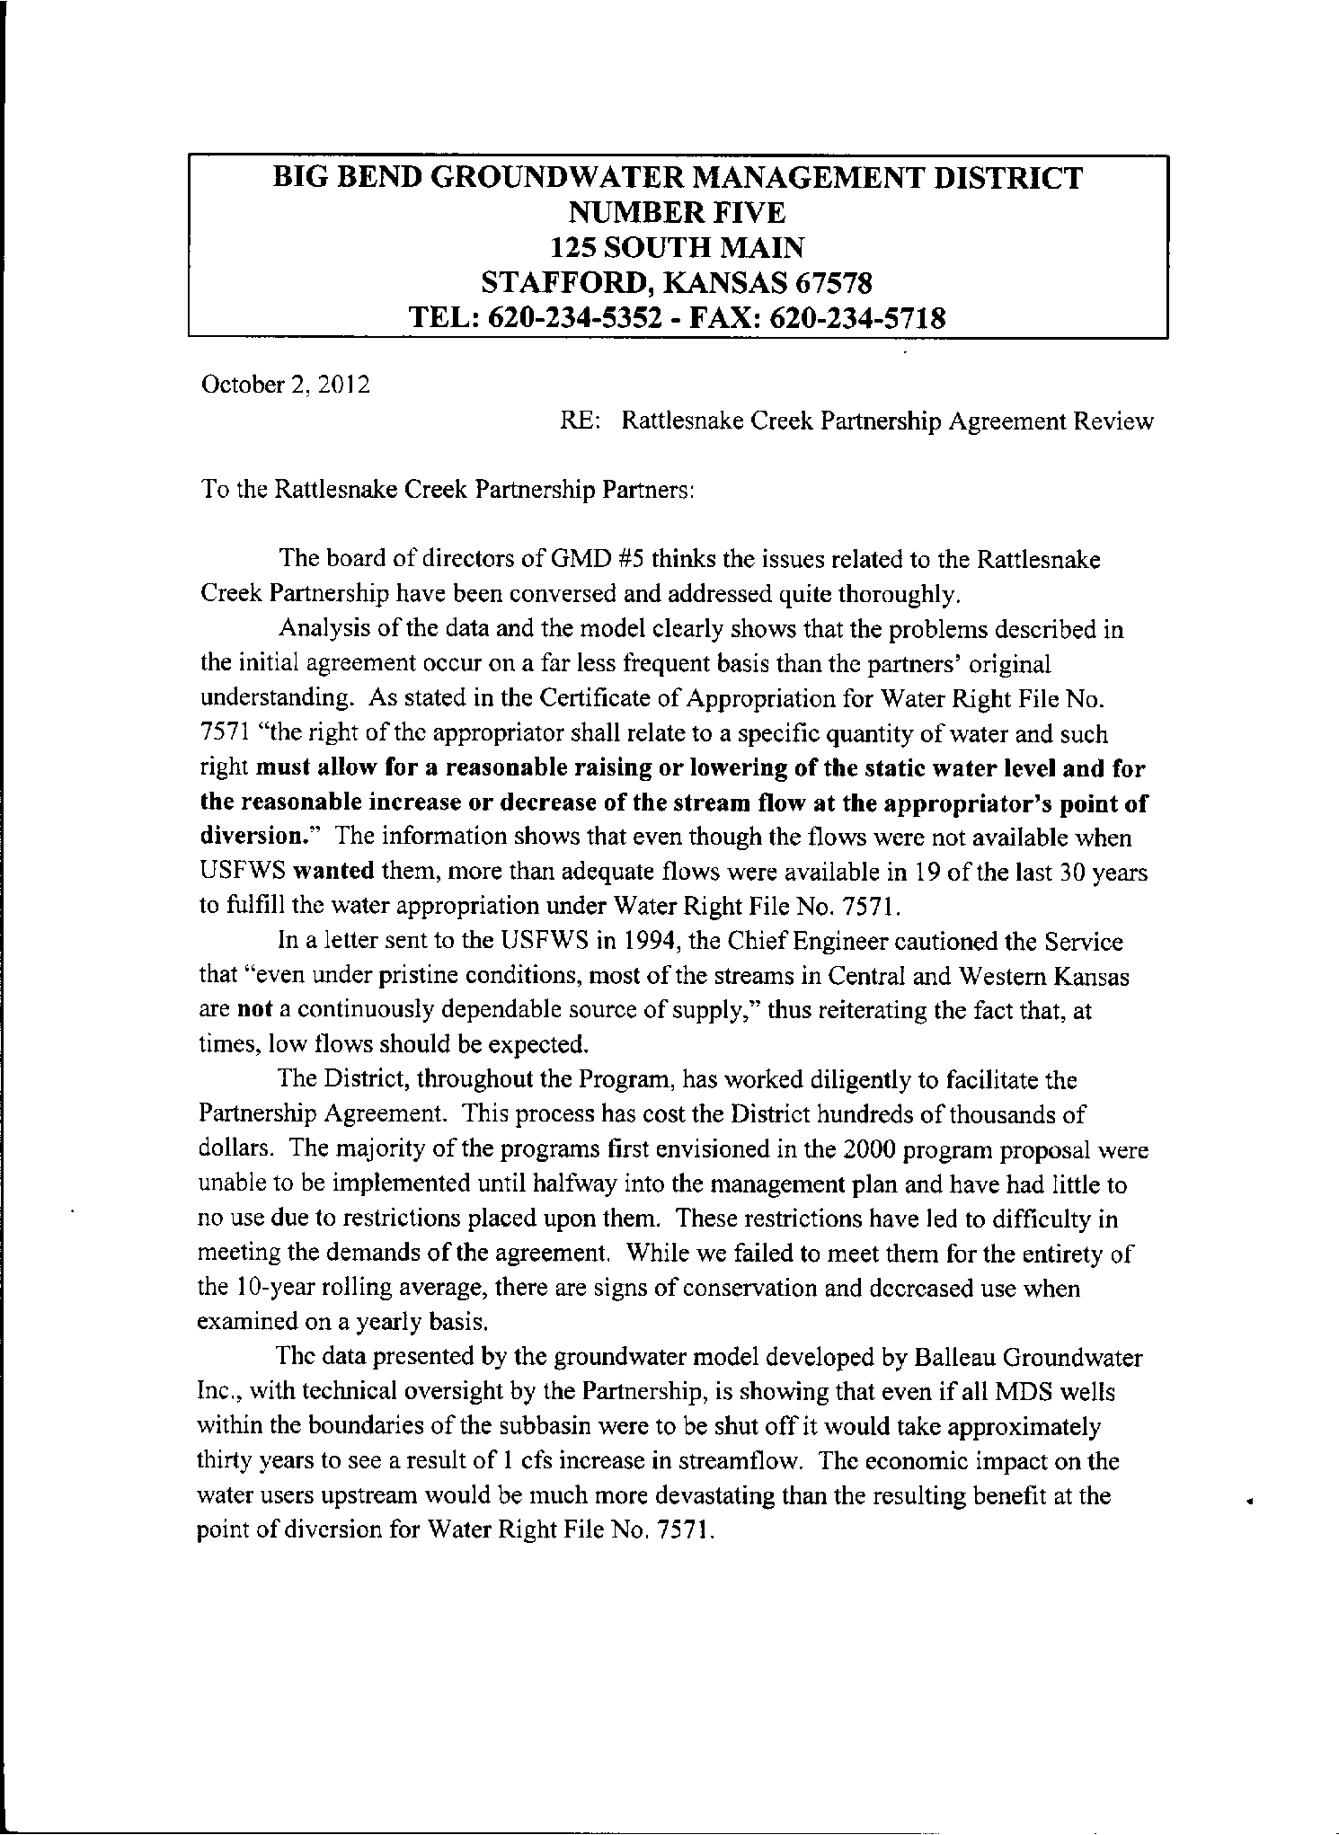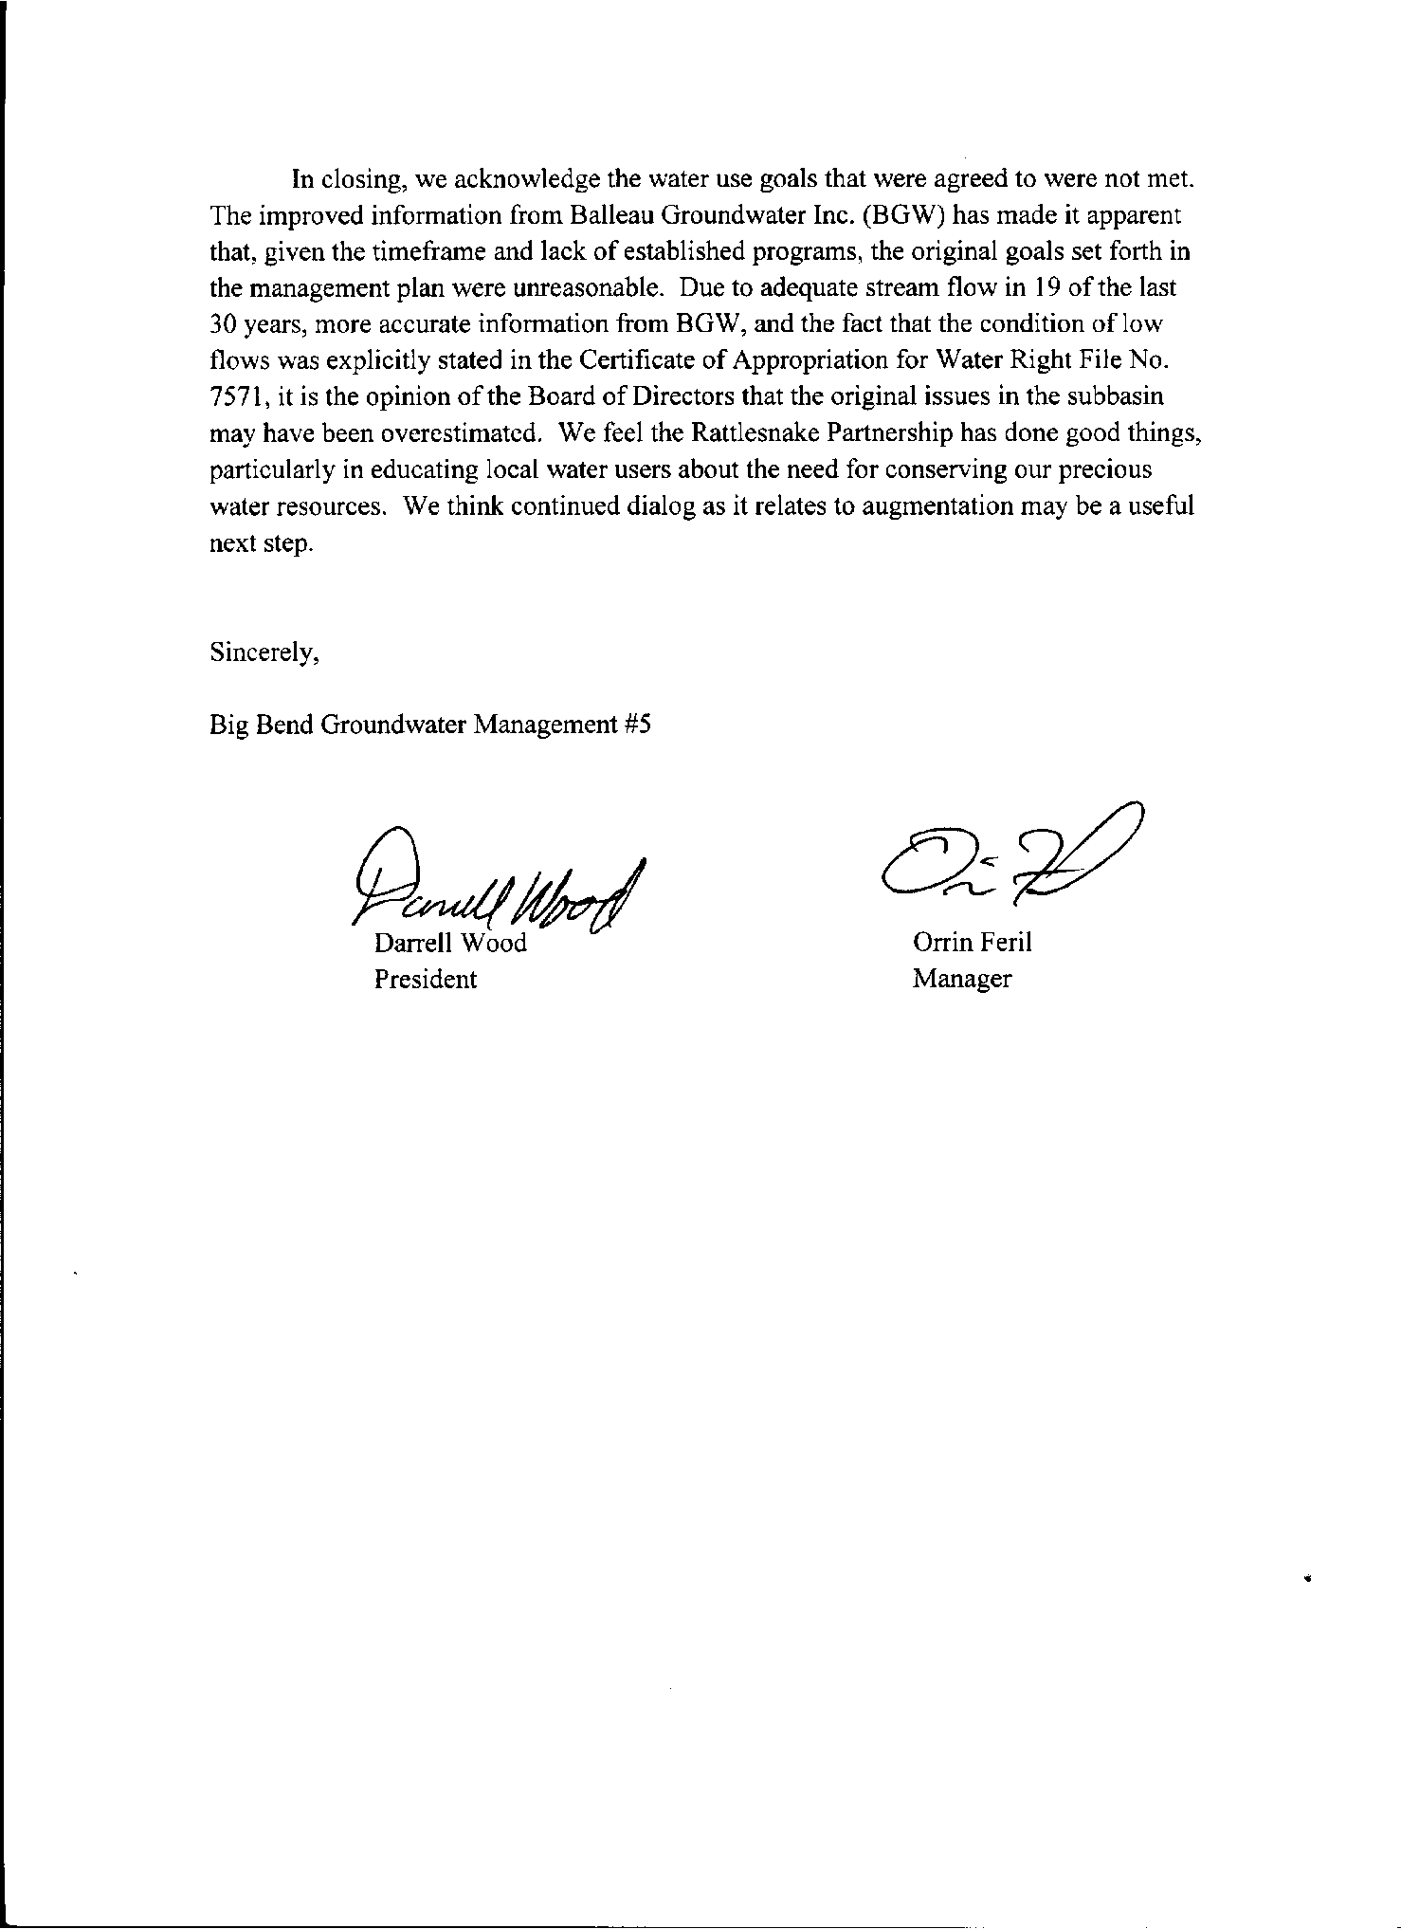

US Fish and Wildlife Service (USFWS) –

USFWS Perspective
Quivira National Wildlife Refuge (QNWR) was established primarily to conserve habitat for spring and fall migrating and wintering birds in the Central Flyway, and to support nesting and resident wildlife and their associated environments. The availability of water resources is important year-round on the QNWR to provide food and cover requirements for different wildlife and life-cycle events. It is necessary to vary water management prescriptions on the QNWR seasonally and yearly to maintain productive wetlands. Despite having a senior water right, water is not always available for use when the QNWR needs it to manage habitat for wildlife, particularly in late summer when groundwater pumping for cropland irrigation is still occurring within the Rattlesnake Creek Subbasin.

Water Use and Water Management
Many studies and models describe the water resource system in the Great Bend region of south central Kansas and areas within Groundwater Management District Number 5 (GMD-5) (Jantzen, 1960; Koelliker, Zovne, Steichen, & Berry, 1981; Cobb, Colarullo, & Hiedari, 1983; GEI Consultants, Inc,; Burns and McDonnell, 1998; Balleau Groundwater, Inc., 2010). This includes undeniable evidence of the connection between the groundwater aquifers and the surface water system, and presents theories on the dynamics of the system. Groundwater use for irrigation in GMD-5 is lowering the static water level in wells. Preliminary data for the 12 year review of the Rattlesnake Creek Partnership proposal show that instead of reducing groundwater use in the Rattlesnake Creek sub-basin, most areas show increased groundwater use (Basin Management Team, 2012), despite above average precipitation in recent years. Long-term conservation of water toward sustainable water use requires both social and political management to be effective.

Several revisions to Kansas water law occurred that do not consistently support conservation of water resources and protection of senior water rights. To relieve drought stresses, temporary Emergency Drought Term Permits allow pumping irrigation water beyond appropriated quantities. In these cases, 2011 pump overages were borrowed from 2012 allotments. Also, the Kansas Legislature passed SB-272 that enables multi-year flexibility in water use (Kansas Legislature Committee on Agriculture, SB-272, 2012). Multi-Year Flex Accounts encourage water conservation by “saving” unused water in a particular year for “possible” use in subsequent years. Wording in SB-272 forgives water debts from Emergency Drought Term Permits in 2011. The immediate effect of these Multi-Year Flex Accounts allows groundwater pumping during times when aquifer levels are most susceptible to depletion, affecting streamflow in Rattlesnake Creek and water deliveries to the QNWR.

Groundwater discharge from the Alluvial and Great Bend aquifers is the primary mechanism that provides base-flow in Rattlesnake Creek. Groundwater conservation programs and administration by the State is necessary to preserve the groundwater resources in the region and thereby protect the surface water rights of the QNWR. As stewards of our natural resources we have an urgent challenge to act responsibly with effective and sustainable water conservation and protection.

USFWS Concerns
Several concerns were raised by the USFWS during the comment period for the Rattlesnake Creek Partnership DRAFT Third Four-Year Review of Management Program report. Many of these comments were removed from the final draft version of the report, with the recommendations to include them in the USFWS Position Statement. Comments are summarized:

- Insufficient groundwater-use reductions occurred to contribute to streamflow depletion.

- 2011 marked the end of a relatively wet period in the subbasin, evidenced by both groundwater levels and climate conditions. Groundwater levels experienced decline throughout most of the subbasin during the 2001-2012 period despite the relatively wet climate.

- The management program established a goal to meet and maintain a 10-year rolling average of 25 cfs at the Zenith gage during the month of January. The Partnership agreed that 25 cfs in January would effectively demonstrate aquifer recovery following irrigation depletions, and provide sufficient baseflow to ensure MDS criteria flows through the summer. Beginning in 2009, the 10-year rolling average dropped below the 25 cfs objective and has remained below since, indicating a negative trend in streamflow, despite above average precipitation since 2004.

- The Partnership agreed to specific Management Program goals for water use reduction. The management goal for the Water Right Conservation Program is 7,396 acre-feet. The water savings attributed to the Water Right Conservation Program is 188 acre-feet, or a 2.54% success rate. Two of the water rights expire from the Water Right Conservation Program in December 2012. The water savings attributed to the Water Banking Act is 100 acre-feet, compared to the management goal of 2,390 acre-feet, or a 4.18% success rate. The water savings attributed to the Voluntary Removal of End Guns program represents a 12.8% success rate, saving 712 acre-feet of the 5,562 acre-feet management goal.

- Timing of water is just as important for wetland management as it is for farming practices. Streamflow declines in Rattlesnake Creek directly reduce available water for QNWR management needs, especially in late summer. MDS criteria in Rattlesnake Creek were designed in consideration of natural climate variability to establish minimum monthly streamflow requirements throughout the year. Streamflow below the minimum requirements cause direct suffering impacts to the QNWR by reducing wetland health and affecting critical habitat. Allowing a senior water right (7571) to be impaired while more junior water rights continue to obtain water is inequitable and fails to meet the intent of the law.

- After achieving the water use reduction goals set out in the Rattlesnake Creek Subbasin Management Plan, it may be beneficial to optimize groundwater pumping curtailments using the Balleau GMD-5 Groundwater Model, as long as groundwater use reductions are maintained. The USFWS may be forced to pursue legal actions if the QNWR water right is not protected.

Moving forward from here, the USFWS feels it would be beneficial to all of the Partners if a brief progress summary was provided by KDA on an annual basis. The data being collected and compiled for these Management Program reviews provides objective evidence of water use and the effectiveness of water conservation efforts in the Subbasin. The value of maintaining continuity in the record is vital for future analyses of Rattlesnake Creek hydrology.

Position Of
The Kansas Department of Agriculture – Division of Water Resources
On the implementation of the 2000 Rattlesnake Creek Partnership Management Program

April 24, 2012

The Rattlesnake Creek Partnership (Partnership) management program (Program) has been successful in part and unsuccessful in part when considered against the Program’s originally stated purpose, goals, and objectives to address streamflow depletions and declines in groundwater levels.
The Partnership was formed over 18 years ago to cooperatively develop and implement solutions to water resource problems within the subbasin. Six years of negotiations resulted in the Partnership’s adoption of the jointly developed Program. Considerable time and resources have been expended on data gathering, monitoring, and hydrologic modeling. The subbasin’s variable hydrology, characterized by sequences of dry years with low streamflow and drafting on groundwater storage, and then wet periods with high streamflow and recharge, provides both challenges and opportunities in defining problems and addressing them. Through their participation in the work of the Partnership, each of the partners has increased their understanding of the area’s water resource issues.
The record shows declines in groundwater levels in the western portion of the subbasin and continues to show declines in streamflow–especially baseflow which is critical during dry periods–in the eastern portion of the subbasin.
Over the course of the Program some reduction in water use has been realized through participation in incentive-based programs and enhanced compliance and enforcement, but the annual water savings claimed thus far is less than half of the goal of 27,346 acre-feet of savings laid out by the Partnership in the Program. There has been no significant reduction in irrigated acres and the amount of irrigation water applied per acre has remained generally constant when factoring in the effects of precipitation.
2012 marks the end of the Program’s 12-year implementation period and, based on the record, we conclude that the goals and objectives of the Program have not been met.
The partners should now commit to crafting an enduring solution to the water resource challenges of the area. Negotiated solutions hold the promise of greater flexibility for all partners and may be much more satisfactory to the community as a whole than solutions determined through strict water right administration, state-imposed controls, or other legal processes.
Reductions in water use will be necessary to the long-term solution, but such reductions can and should be implemented in a way that minimizes the impact on the local economy while optimizing the beneficial use of water. There are economic studies and authorities that can help guide these decisions and they should be utilized.
DWR and the other partners need to gain a clearer understanding of the specific needs of Quivira National Wildlife Refuge (QNWR). In order to develop a solution that optimizes the beneficial use of water, U.S. Fish & Wildlife Service representatives need to help the other partners understand the specific water quantities and timings that are essential to the successful operation of the refuge.
The Partners should work to better understand and utilize the newly constructed GMD 5 groundwater model. Among the key uses of the model should be to: (1) gain a clearer understanding of the interactions between groundwater pumping and streamflow in and around the Rattlesnake Creek; (2) simulate the effects of targeted pumping reductions on streamflow and groundwater levels and; (3) simulate the location, operation, and hydrological effects of augmentation well(s) that could help address the needs of QNWR.
The 2012 Legislature created an administrative management tool that allows a groundwater management district to initiate a process, then develop and implement corrective controls to address water resource issues. This new tool–the Local Enhanced Management Area (LEMA)–is a proactive option that offers a framework for locally controlled negotiations and solutions and it should be explored.
If the partners are unable to negotiate a solution, two of the possible paths forward seem obvious: (1) implementation of the Alternative Action Management Strategies as per Program section VII which calls for initiation of an Intensive Groundwater Use Control Area process or; (2) QNWR could file a complaint of water right impairment with DWR and request to secure water from junior appropriators whose diversions deplete streamflow in Rattlesnake Creek whether by surface diversion or groundwater pumping.
There are undoubtedly other paths yet to present themselves. We hope that the way forward is characterized by a sincere commitment from each partner to understand each other’s concerns and constraints and that a mutually agreeable solution can be achieved.
DWR will consider, without prejudice, all options that conform to the law and are in the public interest.

